The transition to a sustainable economy is not sustainable: an ecological macroeconomic analysis of climate policy, the circular economy, and global inequality

Oriol Vallès Codina, José Bruno R. T. Fevereiro, Annina Kaltenbrunner, Effie Kesidou, Andrea Genovese, Marco Veronese Passarella

ABSTRACT
Circular economy policies are promoted as a pathway to reduce material throughput, emissions, and resource use. Yet, their macroeconomic and transnational effects are not well understood. This paper develops a two-region ecological macroeconomic model with a multi-regional input–output structure and stock–flow consistent dynamics, calibrated for the European Union (EU) and the rest of the world (RoW). We assess alternative circular economy transition pathways operating through final demand, intermediate production, and investment. The results show that the effectiveness of circular economy policies depends on the scale of the demand channels they target. First, final-demand interventions are impactful only when they engage dominant sectoral channels, such as household consumption in food or government procurement in plastics. Second, intermediate-production restructuring delivers stronger ecological improvements, but at the cost of modest contractions in output and employment. But, this pattern is not uniform. In metals, circular production reduces material use and expands economic activity while increasing emissions due to higher upstream energy intensity. Energy restructuring delivers the largest emission reductions due to both scale and intensity differentials. Finally, investment-driven transitions can generate large macroeconomic effects but may also entail adverse environmental outcomes under current technological conditions. Overall, the paper shows that circular economy transitions generate systematic transnational trade-offs. This suggests the need for coordinated policy frameworks that align circularity with decarbonisation, macroeconomic stability, and international considerations.

Introduction
The transition to sustainability is nowadays understood to go beyond the energy transition, requiring adoption of circular-economy (CE) strategies that seek to reduce material throughput, as well as emissions, increasing efficiency in resource use (Geissdoerfer et al., 2017; Korhonen et al., 2018). In recent years, the global policy landscape has begun to shift from high-level "roadmaps" to legally binding regulations and sector-specific enforcement (Barrie et al. 2024). Results from most academic studies, conducting ex-ante analysis, have projected positive environmental and socio-economic impacts of the adoption of CE strategies, specially, at the national or regional level (Agullar-Hernandez et al., 2018, and Fevereiro et al., 2025). Yet, the effects of circular transition cannot be assessed only in the country where policy is legislated. This is because production networks, trade relations, and financial hierarchies connect countries and regions asymmetrically. This implies that policies designed for green production and consumption in advanced economies may reallocate costs, demand pressures, and ecological burdens across countries rather than resolve them globally (Wiedmann et al., 2015; Dorninger et al., 2021). Moreover, recent research suggests that circularity and decarbonisation do not necessarily move together, since circular initiatives can generate energy-intensive processes, upstream emission increases, or burden shifting across supply chains when they are not coordinated with broader net-zero strategies (Arranz et al., 2026).
This problem matters because circular-economy policy often is analysed from technical or managerial perspectives that emphasise recycling, efficiency, product-life extension, or demand shifts (Kirchherr et al., 2017; Geissdoerfer et al., 2017). Less attention is paid to the structural relations through which environmental benefits and socio-economic costs are distributed internationally, and to the fact that different circular-economy channels do not have the same macroeconomic or ecological effects. However, circular transitions occur within a global economy that is characterised by unequal ecological exchange, persistent structural asymmetries, and monetary and financial constraints (Hornborg, 2009; Hickel et al., 2022). Here, therefore, we argue that the question is not whether circular-economy practices, in isolation, reduce emissions or material extraction, but (i) under what conditions they do so, (ii) for whom, and (iii) through which demand and production channels, and (iv) with what global macroeconomic and distributive consequences across regions.
Recent research in ecological economics and political ecology shows that environmental improvements in high-income economies are typically associated with the externalisation of extraction, energy use, labour, and waste-intensive production through trade and global value chains (Wiedmann et al., 2015; Dorninger et al., 2021). This implies that circular-economy policies cannot be assessed only using domestic indicators of efficiency or decarbonisation. Ecological gains in the centre might actually rely on the continued ecological appropriation of labour, land, energy, and materials from the periphery (Lenzen et al., 2012; Hickel et al., 2022). Additionally, research on degrowth and global dependency indicates that ecological transition is driven by a “twin problem”. That is the material excesses of the Global North make transformation necessary, while North–South dependencies constrain the policy space and development opportunities of the Global South (Gräbner-Radkowitsch and Strunk, 2023; Hickel, 2020).
Moreover, research on open-economy ecological macroeconomics suggests that climate policies introduced in the centre may generate contractionary pressures, external imbalances, and financial instability in the periphery, especially when policy coordination is weak and structural asymmetries remain unchanged (Althouse et al., 2020; Campiglio et al., 2018). For example, Fevereiro and Lowe (2025) show that different types of green transition strateges in the Global North (green growth and de-growth) both lead to lower GDP and employment and worsening trade balances in the Global South under existing patterns of specialisation. Furthermore, the current international monetary and financial system limits the ability of many countries in the Global South to absorb shocks, sustain green investment, or pursue autonomous transition strategies, even where “green” finance is available (Svartzman and Althouse, 2020; Volz et al., 2015).
Therefore, building on this literature we propose that circular-economy policy should be analysed as part of a broader political-ecological and global macro-financial structure rather than as an isolated set of efficiency-enhancing strategies or policies. Moreover, we argue that it is important to distinguish between the channels through which circular-economy interventions operate. This is because the effectiveness of such policies depends on whether they operate through final demand, intermediate production, or investment dynamics. Crucially, these distinct channels can generate different macroeconomic, social, and ecological outcomes, implying that the effectiveness of circular economy policies is contingent on the choice of the channel.
Our paper addresses this gap through a two-region ecological macroeconomic model with a multi-regional input–output structure and stock–flow consistent dynamics, which is calibrated for the European Union (core) and the rest of the world (periphery). By combining ecological extensions with a macro-financial open-economy framework, the model allows us to analyse circular-economy scenarios as structurally differentiated transition regimes rather than isolated technical shocks. Specifically, we compare how changes in final demand, intermediate production, and sectoral expansion affect value added, employment, distribution, fiscal and current-account balances, emissions, and material extraction across the core and the periphery regions. In doing so, we examine how circular-economy policies generate transnational socio-ecological trade-offs and cross-regional macro-financial asymmetries.
We apply this model to analyse
Our results do not point to a single CE transition regime. They demonstrate a set of channel- and sector-specific outcomes. We find that the magnitude of ecological and macroeconomic effects is determined by the size of the demand channel targeted. First, final-demand interventions are not low-impact. Their effectiveness depends on whether they engage the leading channel of sectoral demand. For instance, household food transitions generate the largest employment and material effects among final-demand scenarios, while government procurement constitutes a key policy lever for plastics due to its unusually large demand share.
Second, intermediate-production restructuring delivers stronger ecological outcomes, particularly in sectors where intermediate demand dominates, but often at the cost of modest contractions in output and employment. However, this pattern is not universal. The metals production scenario illustrates a structural rebound effect. This means that material use declines and economic activity expands, yet emissions increase due to the higher upstream energy intensity of secondary metal production. In contrast, energy production restructuring delivers the largest emission reductions across all scenarios. This reflects the combination of large intermediate demand and a high emission intensity differential between fossil and renewable energy.
Third, construction-related transitions occupy a different position. Construction is a key cross-material demand and generates large macroeconomic effects due to its scale. Both demand-side and production-side construction scenarios show that circular construction can increase emissions despite reducing material throughput. This happens because of the high energy intensity of secondary construction processes under current technological conditions.
Across the full set of scenarios, the results show a key structural pattern, namely that circular-economy transitions are characterised by transnational socio-ecological trade-offs. Ecological improvements, macroeconomic performance, and distributional outcomes do not move together automatically. In particular, high-leverage transitions, such as energy and metals, generate asymmetric cross-regional effects, including shifts in employment, external balances, and fiscal positions between the EU and the rest of the world.
This paper contributes to the ecological economics literature in three ways. First, it integrates circular-economy analysis with ecological macroeconomics in an open-economy, multi-regional framework. Second, it introduces a channel-based perspective that distinguishes between final-demand, intermediate-production, and investment-driven transition pathways. Third, it demonstrates that circular-economy policies generate systematic transnational trade-offs, and shows that these trade-offs are structurally embedded in the global production system.
The findings of this paper challenge approaches that treat circularity as a purely national, regional or firm strategy. Policies aimed at greening production in advanced economies may improve some domestic indicators while worsening employment, external balances, or ecological pressures elsewhere (Hickel et al., 2022). Therefore, our analysis suggests that a just and effective transition cannot rely on private behavioural change or isolated technical measures alone. It requires coordinated public intervention that re-shapes production structures, considers macroeconomic and distributive trade-offs, and addresses the international asymmetries through which ecological costs are displaced (Campiglio et al., 2018; Volz et al., 2015). More specifically, our analysis suggests that policy design must be channel-specific and complementary, combining demand-side and production-side measures with macroeconomic and institutional coordination.Thus, the paper argues that the key policy divide is not only between linear and circular production, but also between fragmented and cooperative transition strategies, and between circular-economy policies implemented in isolation and those aligned with decarbonisation, macroeconomic stabilisation, and international policy coordination.

Model Overview
In this section we provide a conceptual overview of the main characteristics of the different modules of the model. The analysis relies on a dynamic, ecological, multi-regional input-output, stock-flow consistent (IO-SFC) model calibrated on empirical Input-Output data (Exiobase 3). The model is designed to reproduce the evolution of an interconnected macro-financial-ecological system and to test the implications of alternative circular-economy (CE) trajectories.
Several features are worth highlighting.
- The model operates in discrete time and captures how system-level behaviour emerges from the interaction of its components, laying emphasis on financial-real interactions.
- It enforces stock-flow consistency across all sectors, ensuring that every flow has a corresponding change in a stock and that monetary, real, and physical balances hold by construction.
- The production side is represented through a two-region input-output structure, so all inter-industry linkages - within each region and across regions - are explicitly accounted for.
- The framework is fully open-economy: the world is divided into two regions (the European Union and the rest of the world), connected through goods trade and cross-border portfolio flows.
- Ecological relations are endogenised. Emissions, resource extraction, and waste generation are linked directly to production technologies and material flows.
- Finally, the numerical parameters of the model are anchored in observed data, either drawn directly from existing time series (e.g. technical coefficients) or calibrated to replicate the prevailing levels of key macroeconomic aggregates.
In recent years, several authors (e.g., Hardt and O’Neill 2017; Bimpizas-Pinis et al., 2023; Fevereiro et al., 2025) have identified the combination of input-output (IO) analysis and stock-flow consistent (SFC) modelling as one of the most promising approach for developing models assessing the economy-ecology nexus, including Circular Economy (CE) transition scenarios.
As is well known, IO models are analytical tools used to represent and quantify the interdependencies between different industries of a capitalist economy (e.g., Leontief 1936, 1941). More specifically, IO models illustrate how changes in one industry, such as increased production or consumption, affect other industries through a system of interconnected inputs and outputs, providing insights into the overall economic impact of alternative shocks and policies.
On the other hand, SFC models can be considered a specific class of ‘system dynamics’ tools that replicate the dynamics of a financially sophisticated economy (e.g., Godley and Lavoie 2007, Caverzasi and Godin 2015, Nikiforos and Zezza 2017). In the last decade, SFC models have gained traction in ecological macroeconomics too, due to their ability to integrate consistently and comprehensively the flows and stocks of the real economy, the financial sector, and the ecosystem (Dafermos 2017, 2018; Carnevali et al., 2019, 2020, 2023).
Due to the complexity of an integrated approach, only a limited number of studies have so far incorporated explicitly the IO structure of the economy into a SFC dynamic framework (e.g. Berg et al., 2015; Valdecantos and Valentini, 2017; Di Domenico et al., 2024; Thomsen et al., 2025; Jackson and Jackson, 2025; Pettena and Raberto, 2025; Veronese Passarella, 2025). Nevertheless, some progress has been achieved in recent years. In particular, Veronese Passarella (2023) has extended a standard aggregative SFC model by introducing both a vertical disaggregation (across institutional sectors) and a horizontal disaggregation (across production industries), and has used this framework to explore simple circular economy scenarios. Subsequent contributions have further developed this line of research by broadening the scope of application and refining the treatment of inter-industry and cross-border linkages. For instance, Fevereiro et al. (2023) have expanded on Veronese Passarella (2023)’s analysis by applying it to a two-area economy. This extension explicitly considers the effects of international trade, supply-chain interdependencies, cross-border portfolio investments, and exchange rate fluctuations.
Formally, the model consists of accounting identities and behavioural equations relating industries and institutional sectors. These are organised into three blocks: the economic–financial block, the social block, and the ecological block.
Economic and Financial Block
Each region comprises five institutional sectors: households, private firms, government, commercial banks, and the central bank. The institutional structure of the economy is identical in the two regions, and in the baseline no trade constraints or financial restrictions are imposed.
Households earn wages and capital income (distributed profits, interest, and capital gains) and allocate their disposable income across consumption and asset holdings. Consumption is a fixed function of disposable income and wealth, while portfolio allocation follows a Tobin-type mechanism based on relative returns and liquidity preferences. Households may take out personal loans to finance durable consumption or expenditure exceeding current income.
Contrary to a typical SFC model, private firms are disaggregated into 54 productive sectors based on IO data. Unless explicitly affected by change in one of the scenarios tested, firms operate under assumption fixed input proportions (Leontief technology) and constant returns to scale assumption. Industries produce homogeneous outputs and set prices via mark-ups over unit costs, which include intermediate inputs, labour costs and the depreciation of the capital stock. Firms adjust their capital stock toward a target capital–output ratio; this generates investment demand even when output is constant. Investment is financed through retained earnings, bank credit, and the issuance of shares purchased by domestic and foreign households.
Government consumption expenditure - both consumption and public investment - is exogenous. Revenues accrue from income taxes, VAT, import duties, and central-bank profits. Budget deficits are financed through the issuance of government bills. Central banks accommodate the demand for currency and purchase the portion of government debt not absorbed by the private sector. The policy rate set by the central bank determines the interest rates on loans, deposits, and government bills through sector-specific mark-ups.
Commercial banks supply credit elastically: firms receive all the financing they require for production and investment. Deposits exceeding the volume of loans are placed in government bills; if loans exceed deposits, banks borrow from the central bank.
In the CE scenarios, part of the waste stream is diverted to a recycling industry that produces secondary inputs. This is implemented through changes in the relevant input–output coefficients.

Social Block
Although households are modelled as an aggregate sector, the framework tracks the distribution of income and wealth between workers and rentiers, both before and after taxes. This allows the model to assess distributional consequences of alternative CE trajectories.
Employment is determined by industry-specific labour demand. Population dynamics, and thus the size of the labour force, follow exogenous demographic growth and net immigration inflows. Cross-regional migration reacts to population size, unemployment differentials, and wage gaps.

Ecological Block
The ecological sub-model follows recent advances in ecological SFC modelling. Waste generation is tied to industrial production through sector-specific coefficients. In the baseline, waste flows are processed by traditional waste-management industries. In CE scenarios, new recycling/reuse channels are introduced.
Industrial CO₂ emissions depend on the use of non-renewable energy inputs. Emissions are determined by energy-intensity coefficients, the share of non-renewables in each industry’s energy mix, and a uniform emissions factor. Accumulated emissions contribute to atmospheric concentrations, which feed into a simplified climate-response module linking cumulative emissions to temperature change.
Material extraction and energy use reflect both new production and the recycling of socio-economic stocks. Renewable energy is replenished periodically, whereas non-renewables are depleted. The size of material and energy reserves evolves according to extraction and conversion flows.

Data Collection and Calibration
Model simulation is carried out in an R environment, using EXIOBASE 3 v 3.8.2, with data calibrated for the baseline year of 2011. The original 164-sector, 49-region classification is aggregated into two regions (EU and rest of world) and 54 sectors, among which 13 sectors specifically produce goods based on re-processed material inputs.
From EXIOBASE data we derive the technical coefficients, labour productivity, real wages, sectoral employment (including gender composition), final demand structure, emissions coefficients, and material-use data required to initialise the technological and environmental parameters. In turn, macro aggregates such as GDP, final demand components, trade flows, and gross output serve as calibration targets.
Remaining parameters are assigned through an evolutionary random-search routine. The algorithm perturbs an initial set of parameter values, evaluates the resulting steady-state values of key variables against their targets, and accepts parameter updates only when the goodness-of-fit improves. This process continues until a satisfactory baseline is reached, subject to constraints ensuring economically meaningful outcomes (e.g., propensity to consume out of class of income-hierarchy conditions).
This calibration phase must also stabilize the system so that, at the moment policy shocks are introduced, the model is near a steady configuration: GDP, trade balances, public deficits, sectoral balances, and stock-flow norms must remain stable over time. The resulting calibration yields a good but improvable match to observed data, with consumption slightly overestimated in the EU and investment underestimated in both regions.

Descriptive Statistics: the Multi-Regional Input-Output Structure of Demand
This section documents the multi-regional input-output (MRIO) structure of demand for eight key material pairs in the EU and Rest of World (RoW), as calibrated in the SOCIO-ECO-MRIO-SFC model at its baseline steady state at t = 70. The figures presented here are descriptive statistics derived analytically from the IO accounting framework without any simulations.

Figure 1 decomposes gross output for all eight material pairs by institutional demand channel (household consumption, government consumption, firm investment, public investment, and firm intermediate consumption) across four regional flow dimensions: EU domestic production for EU demand, EU cross-border imports from RoW, RoW domestic production, and RoW cross-border exports to EU.

Domestic/Cross-Border, Primary/Secondary Composition
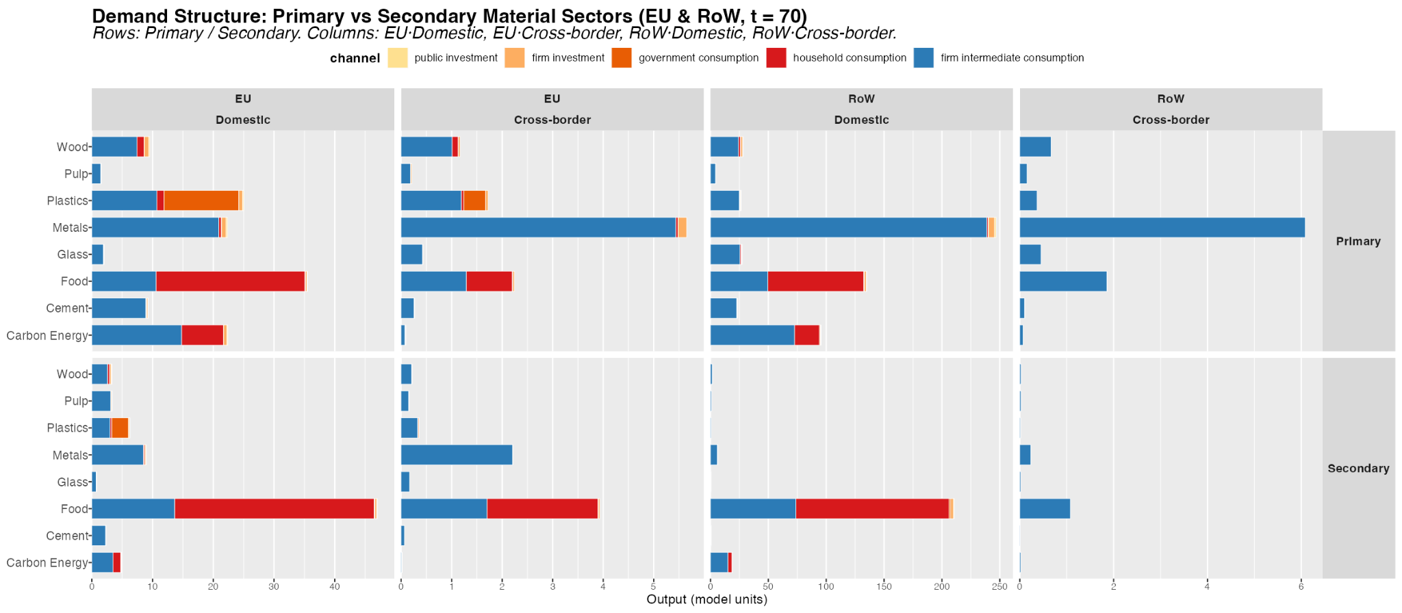
Note: Gross output decomposition for primary and secondary material sectors across EU and RoW. Columns: EU Domestic, EU Cross-border, RoW Domestic, RoW Cross-border demand. Rows: Primary vs Secondary. Bars stacked by institutional demand channel.
Some important patterns are worth highlighting.
Key patterns:
- Industrial materials (cement, glass, metals, pulp) are overwhelmingly driven by firm intermediate consumption, which accounts for 93–96% of gross output in the EU. Final demand channels are negligible. This has direct implications for CE policy design: demand-side instruments (eco-labelling, green public procurement) operate on a structurally marginal share of these markets.
- Food (primary: Meat; secondary: Other Food) stands at the opposite extreme: 65% of EU domestic output serves household consumption. This is the only material sector where a consumer-facing intervention can engage the dominant demand channel.
- Carbon Energy (primary: Fossil-Fuel Electricity; secondary: Renewable Electricity) is structurally intermediate, with approximately 34% final demand (predominantly household electricity consumption) and 66% intermediate. Industrial energy procurement is the primary driver. Secondary output (renewables) is substantially more intermediate-heavy than primary (fossil fuels), reflecting that renewable electricity is primarily procured by industrial users, while fossil-fuel electricity has a larger direct household retail component.
- Plastics present an exceptional structure: while approximately 55% of output serves final demand, this component is dominated by government consumption rather than households. Private investment and household channels are minor. This structural feature of the plastics market makes government procurement a first-order policy lever.
- Primary vs Secondary gap Secondary sectors (recycled/renewable alternatives) are systematically smaller than their primary counterparts in absolute terms. The compositional mix of secondary output also differs – in several materials, secondary sectors are more intermediate-heavy, suggesting industrial early adopters are leading the transition ahead of final consumers.
- The EU domestic vs cross-border column comparison reveals that cross-border (import) demand tends to be more intermediate-heavy, particularly for manufactured materials (plastics, metals). This reflects the role of global value chains in sourcing industrial inputs from RoW suppliers.

Figure 3: EU Import Structure: EU Demand for RoW Goods
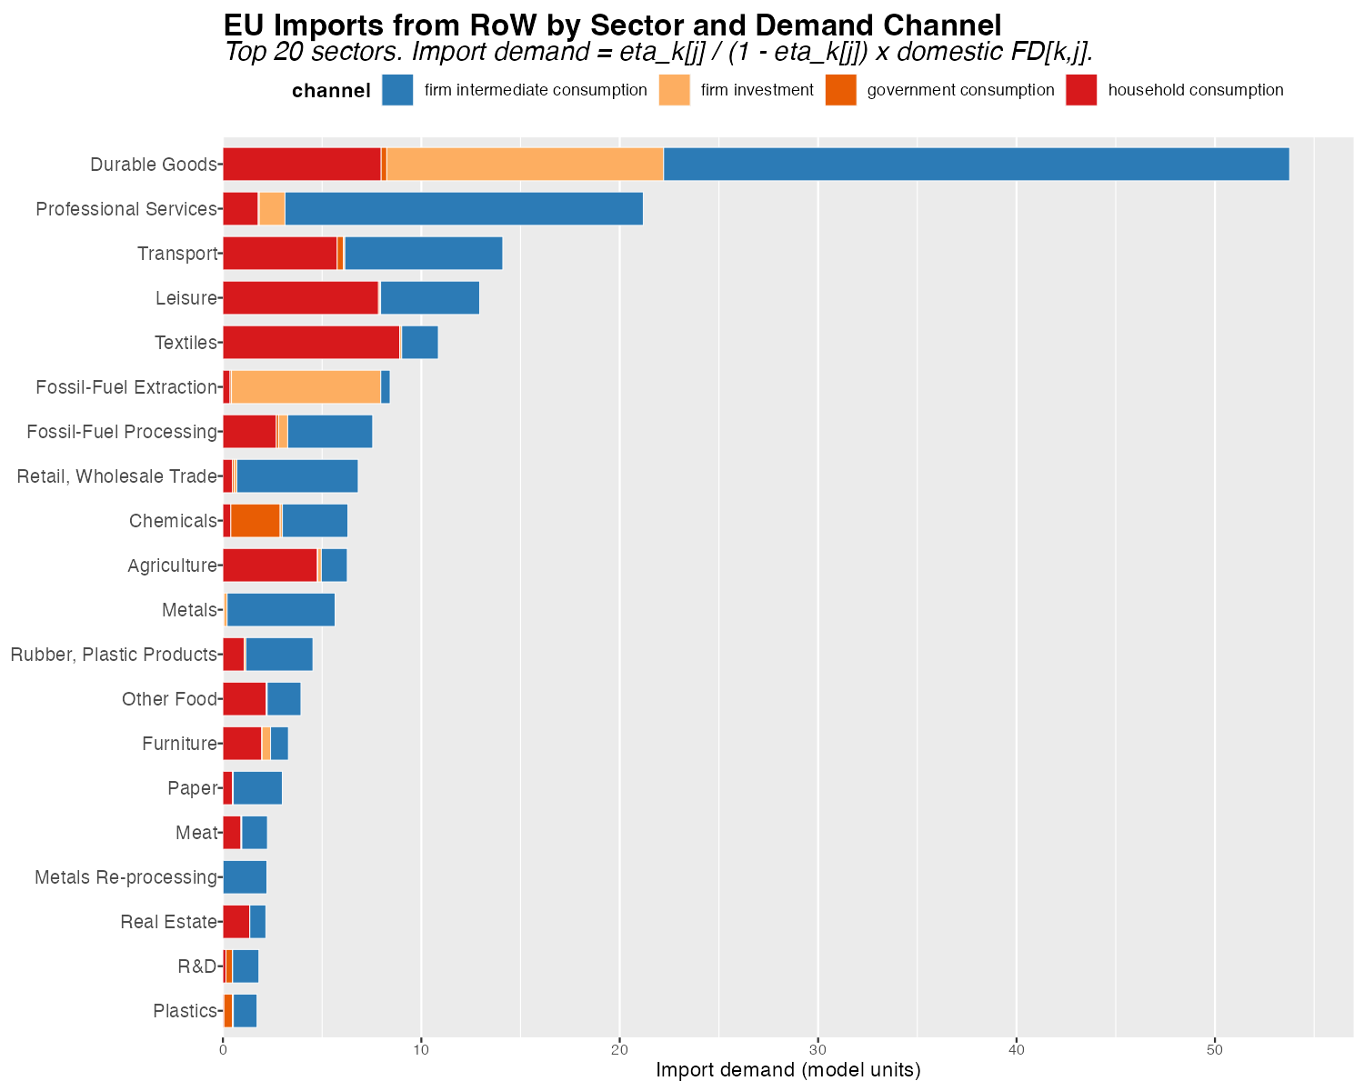
Note: EU import demand from RoW decomposed by sector and demand channel. Includes firm intermediate consumption, household consumption, government consumption, and firm investment. Top 20 sectors by total import demand.
Figure 3 maps the cross-border component of EU demand – imports from RoW – broken down by institutional channel, including both final demand channels (households, government, fixed investment) and firms’ circulating investment.
Key Patterns
- Firm intermediate consumption dominates EU import demand across most high-import sectors. For energy and manufactured goods, the bulk of cross-border purchases are industrial inputs, not consumer goods. This implies that CE policies targeting intermediate production substitution have the largest potential to reduce import dependency alongside domestic primary material use.
- Fossil fuels and carbon energy rank among the highest-import sectors, with a pronounced intermediate consumption component reflecting the EU’s structural dependence on imported fossil-fuel inputs for industrial production processes.
- Government and household consumption import shares are non-trivial for food and certain consumer goods, identifying channels where procurement policy and consumption-side interventions could reduce cross-border material footprints.
- Ranking of sectors by total import demand directly anticipates which CE transitions will generate the largest trade balance improvements in the dynamic simulations: scenarios reducing demand in high-import primary sectors will produce the largest improvements in the EU current account balance.

Leontief Decomposition
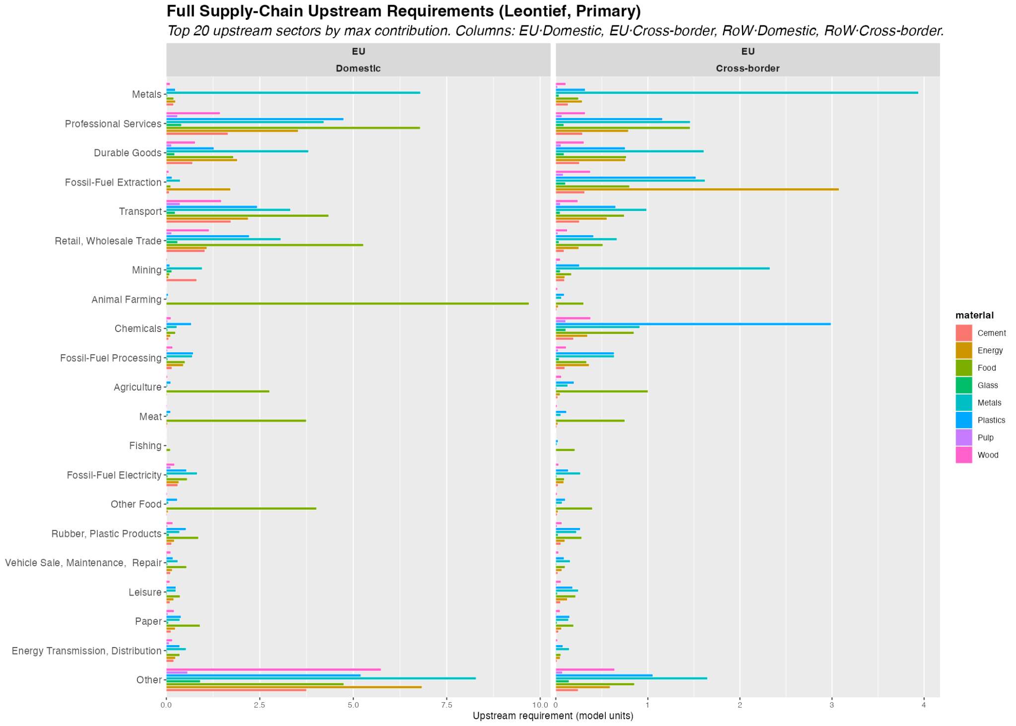
Figure above presents the column view of the Leontief upstream decomposition: 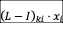, showing which sectors are required as inputs – across all orders of IO interdependence – to sustain the gross output of each material sector . This is the full supply-chain view, encompassing not just direct inputs (captured by the matrix) but all indirect upstream requirements propagated through the IO system.

Key Patterns
- · Animal Farming is the dominant upstream input for Food (primary: Meat). In the EU domestic column (Figure 7), Animal Farming ranks first across the Food material – the full supply-chain view makes explicit what is obvious from the production structure: meat processing draws on livestock rearing across all IO orders. Notably, in the EU cross-border column, Fossil-Fuel Electricity and Metals appear as significant cross-regional upstream requirements, connecting food production to global energy and industrial supply chains.
- · Fossil-fuel extraction and processing are the dominant upstream inputs for primary Carbon Energy (Fossil-Fuel Electricity). This connection – invisible in direct intermediate demand statistics – becomes salient in the full supply-chain view. Primary fossil-fuel electricity generation draws heavily on fossil-fuel extraction (EU domestic) and fossil-fuel processing as upstream requirements across all IO orders. This validates the model’s treatment of carbon energy scenarios as a pivot point for cross-sectoral decarbonisation.
- · Metals shows the largest aggregate Leontief contribution across all material sectors, driven by the economy-wide role of metals as an input to machinery, infrastructure, and energy systems. Crucially, comparing the primary (Figure 7) and secondary (Figure 8) columns for Metals reveals the precise mechanism behind the emission rebound quantified in Section 7. The structural factor acts symmetrically: shifting demand from primary (sector 26) to secondary (sector 27) reduces upstream requirements for sector 26 by unit (, ) and increases requirements for sector 27 by unit (, ). Because Metals Re-processing is itself more emission-intensive than primary Metals ( vs ), the increase in sector 27 requirements costs more in emissions (+443) than the reduction in sector 26 saves (−293). A secondary contribution comes from Fossil-Fuel Electricity (sector 31), which secondary metals requires more intensively (), adding +74 to the rebound due to its very high emission intensity (). The savings from reduced Mining and Fossil-Fuel Extraction – inputs that primary metals needs for iron ore and coal – partially offset these but are insufficient to reverse the net sign.
- · Primary vs secondary supply-chain divergence: Comparing Figures 7 and 8, secondary sectors generally exhibit different upstream structures relative to their primary counterparts. Secondary Carbon Energy (Renewable Electricity) has substantially lower fossil-fuel upstream requirements, confirming the ecological rationale for the transition. For Metals, the divergence works in the opposite direction for emissions – secondary Metals Re-processing requires more of itself and more fossil-fuel electricity – producing the rebound documented in Section 7.
- · The EU–RoW cross-border column reveals which upstream requirements are supplied cross-regionally. For Carbon Energy and Metals, significant upstream requirements originate from RoW sectors, underscoring the importance of global supply chain dynamics in evaluating the full ecological impact of EU CE transitions.
- · Sector ordering (largest aggregate contribution at top) reveals that energy-related sectors, Animal Farming (for Food), construction, and financial/business services constitute the dominant upstream inputs across materials – reflecting the economy-wide energy, agricultural, and services intensity of all production processes.

Circular Economy Policy Portfolio Effectiveness
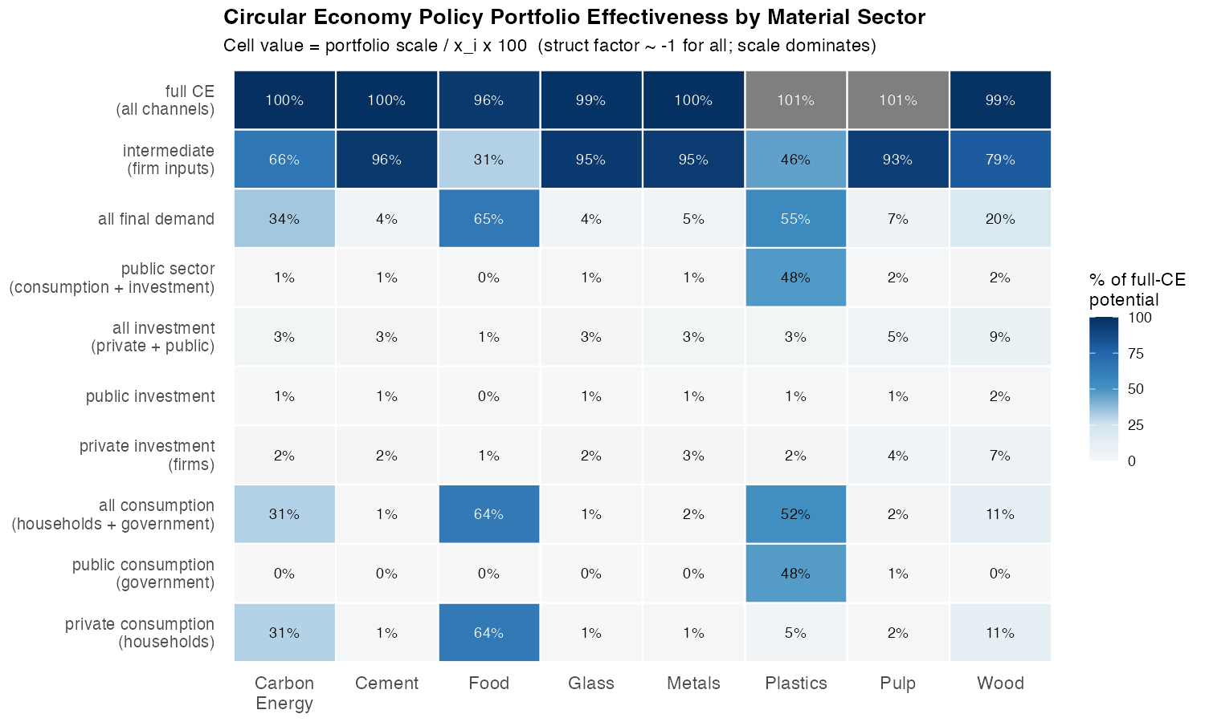
Figure 4: CE policy portfolio effectiveness by material sector. Cell values report the portfolio scale as a percentage of gross output x_i, which – given the structural factor (l_i2 - l_i1) approximately -1 for all materials – equals the percentage of full-CE potential captured by that portfolio at substitution intensity rho = 0.2.
Figure 4 systematically compares the effectiveness of seven CE policy portfolios regarding the demand channels across eight material sectors, providing the key analytical bridge between the IO structure and the simulation outcomes. Because the structural factor is approximately constant across all material pairs, differences in simulation outcomes will be driven almost entirely by differences in the structure of the demand under intervention, not by variation in the IO multiplier. The heatmap therefore anticipates the ordering of cumulative material savings, emission reductions, and macroeconomic effects across scenarios.
Key Patterns
- Intermediate production substitution dominates for all industrial materials. For cement, metals, glass, and pulp, the intermediate channel alone captures 93–96% of the full-CE benchmark. Any final demand portfolio – even combining all four institutional components – recovers less than 8% of potential. This is not a marginal advantage of production-side policy; it is a categorical difference in order of magnitude.
- Plastics: government procurement equals intermediate substitution. For plastics, the government consumption channel alone (47.5%) is comparable to the intermediate channel (45.9%) and far exceeds household consumption (4.6%). This formal equivalence – unique among the eight materials – reflects the institutional dominance of government procurement in the EU plastics market and makes circular public procurement a first-order policy instrument alongside production-side regulation.
- Food: the household channel leads. At 63.8%, household consumption is the dominant CE lever for food – the only material where this is true. Even so, the intermediate channel adds a complementary 31%, pointing to the importance of food processing and catering supply chains.
- Carbon Energy: firm intermediate dominates over household behaviour. Despite public discourse focusing on household energy transitions, household consumption captures only 30.6% of the full-CE potential for carbon energy. The intermediate channel captures 66.1%. Industrial energy procurement – not consumer behaviour – is the primary driver of fossil-fuel electricity demand.
- Carbon energy transitions generate by far the largest absolute emission and material reductions. The intermediate channel alone yields (10t CO₂eq) at , and the full-CE portfolio yields . This reflects both the large portfolio scale (intermediate channel dominates at 66%) and the high emission intensity of fossil-fuel electricity generation.
- Structural rebound is a real constraint for industrial materials. For glass, cement, and metals, the secondary sector’s upstream supply chain is currently more emission-intensive than the primary sector’s. For Metals, the Leontief decomposition identifies two specific channels: (i) Metals Re-processing is itself more emission-intensive than primary Metals (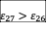), so the symmetric increase in sector 27 requirements outweighs the reduction in sector 26; and (ii) secondary metals requires more fossil-fuel electricity than primary metals (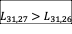). Both channels must be addressed – through decarbonisation of the electricity grid and cleaner reprocessing technology – before CE transitions in metals can deliver net emission reductions.
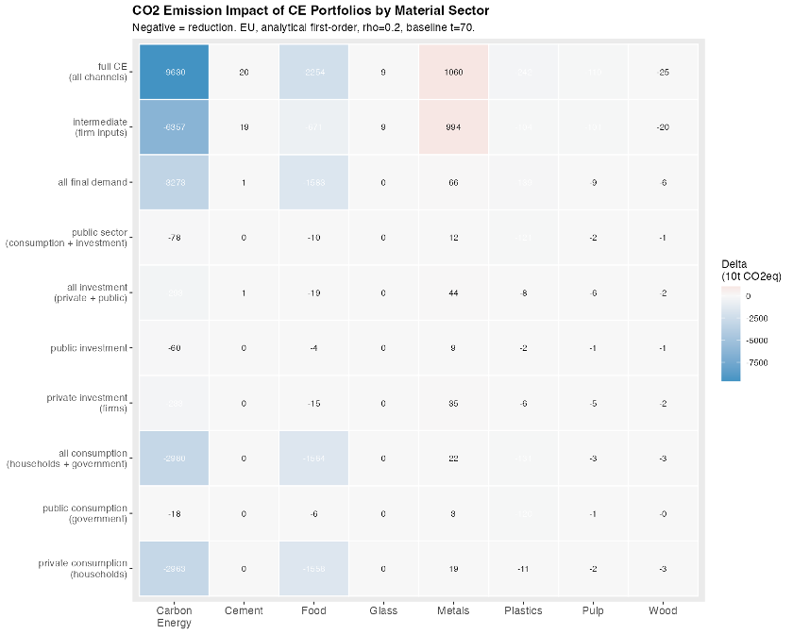

Scenario Analysis and Discussion
In this exercise we ran 14 alternative shocks connected with CE practices, which are categorized among their domains (final or intermediate demand), institutional sector implementing the CE practice (Household, Government or Firm), the demand component shocked (
the final (shocks 1 to 7) or intermediate inputs (shock 7 to 14) domains. Among the CE shocks affecting

Scenario Registry
shock | domain | sector | Demand component | shift | target | primary | secondary | rho
1 | Final Demand | Household | Consumption | Food | beta | 7 | 8 | 0.20
2 | Final Demand | Household | Consumption | Energy | beta | 31 | 32 | 0.20
3 | Final Demand | Household | Consumption | Wood | beta | 11 | 12 | 0.20
4 | Final Demand | Government | Consumption | Plastics | sigma | 17 | 18 | 0.20
5 | Final Demand | Firm | Fixed Investment | Construction | iota | 36 | 37 | 0.05
6 | Final Demand | Firm | Fixed Investment | Metal | iota | 26 | 27 | 0.20
7 | Intermediate Demand | Firm | Intermediate Demand | Wood | a | 11 | 12 | 0.20
8 | Intermediate Demand | Firm | Intermediate Demand | Pulp | a | 13 | 14 | 0.20
9 | Intermediate Demand | Firm | Intermediate Demand | Plastics | a | 17 | 18 | 0.20
10 | Intermediate Demand | Firm | Intermediate Demand | Metal | a | 26 | 27 | 0.20
11 | Intermediate Demand | Firm | Intermediate Demand | Glass | a | 21 | 22 | 0.20
12 | Intermediate Demand | Firm | Intermediate Demand | Cement | a | 24 | 25 | 0.20
13 | Intermediate Demand | Firm | Intermediate Demand | Energy | a | 31 | 32 | 0.20
14 | Intermediate Demand | Firm | Intermediate Demand | Construction | a | 36 | 37 | 0.05

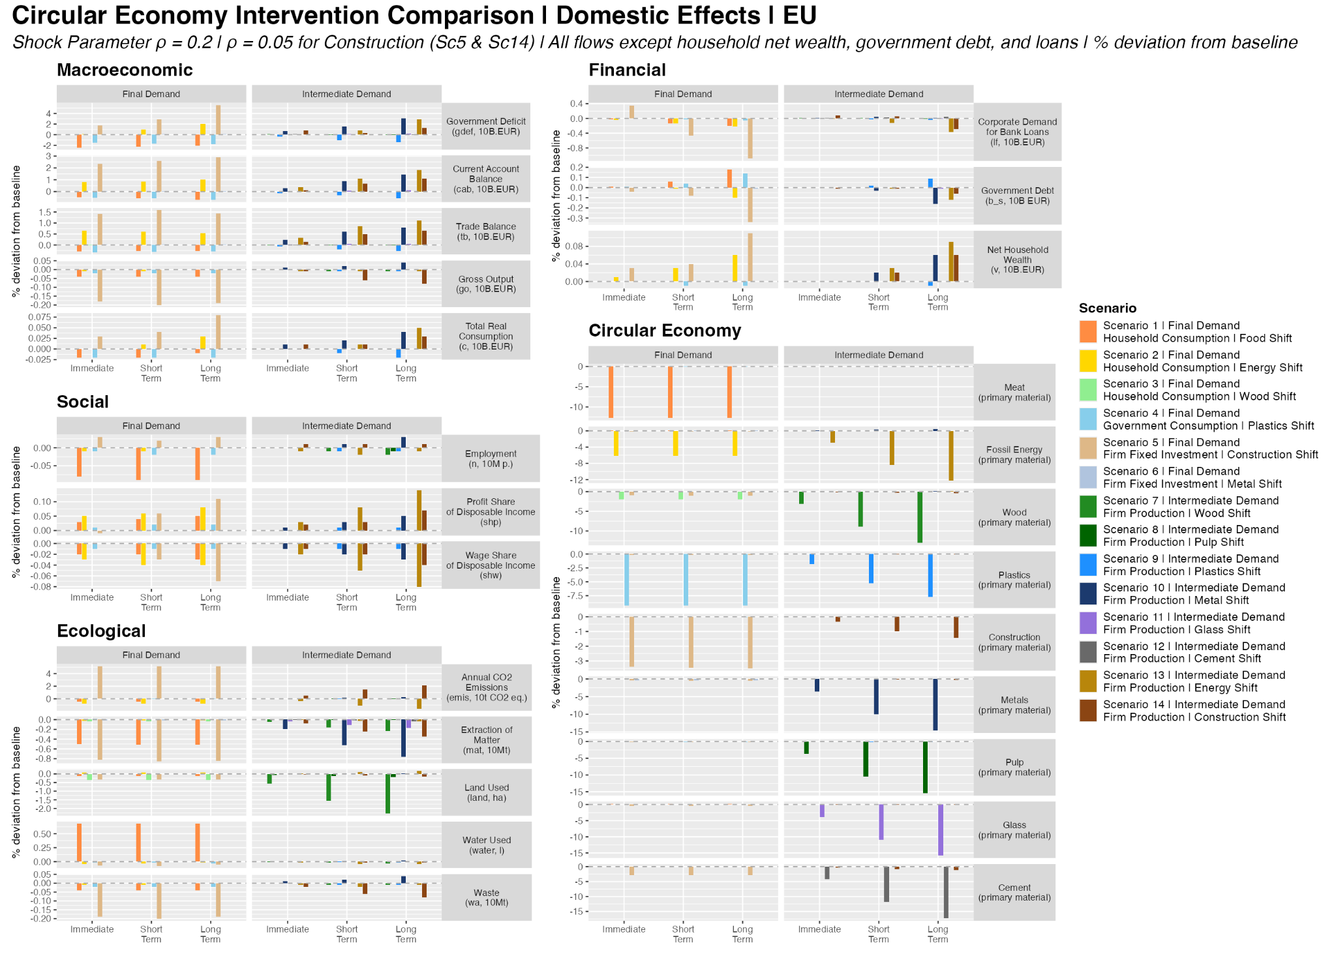

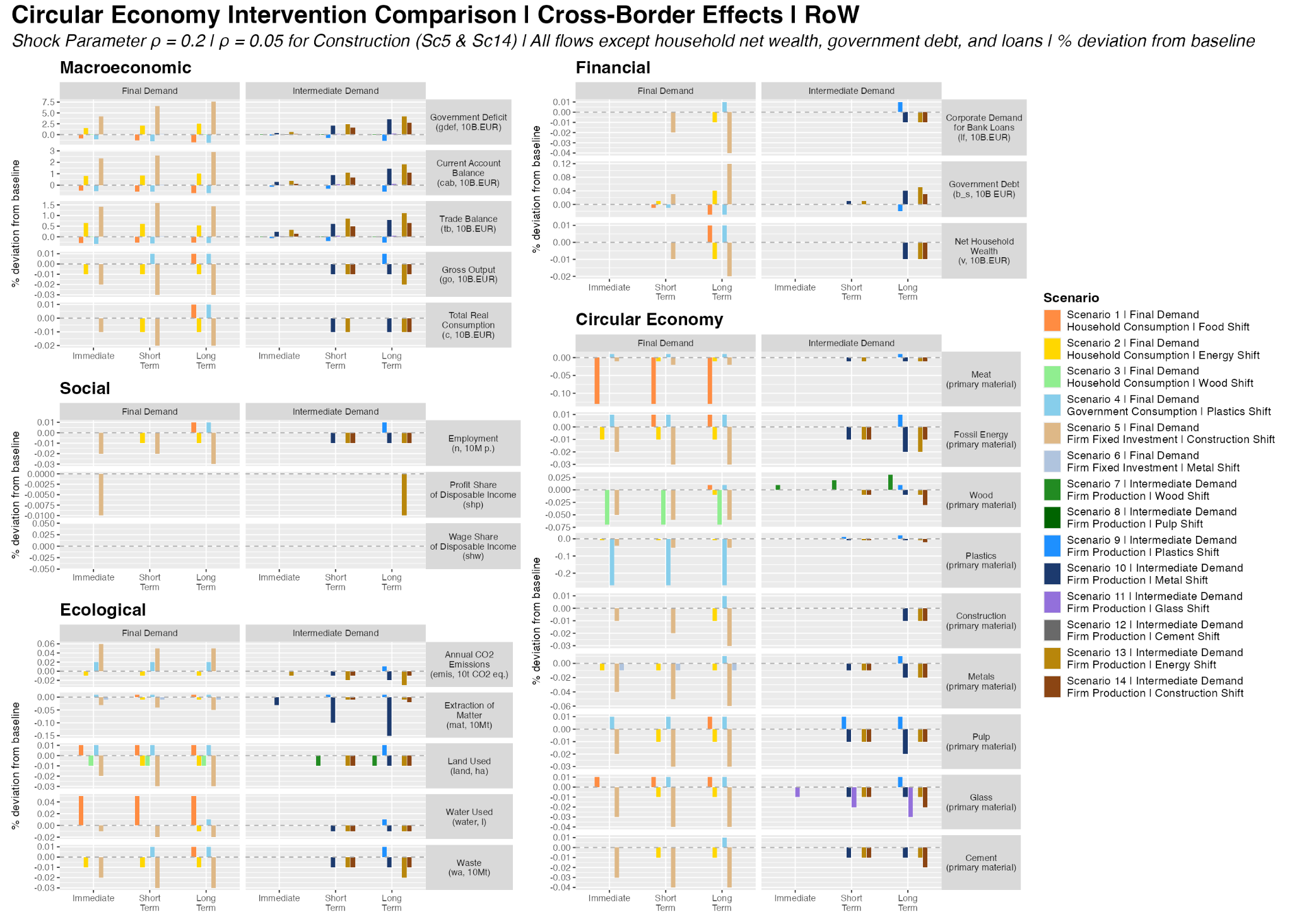(cross-border) effects.
The comparison figures present all 14 scenarios simultaneously across three time horizons: Immediate (t+1), Short-Term (t+7), and Long-Term (t+20). The integrated figure (08/09) organises variables into five categories across two columns: Macroeconomic, Social, and Ecological on the left; Financial and Circular Economy sector outputs on the right. Separate figures are produced for EU (domestic) and RoW

The Portfolio Scale Principle
The most robust finding across all 14 scenarios is that the rank ordering of outcomes is predicted by the absolute scale of the targeted demand channel, not by material-specific multiplier variation or sectoral intensity alone. The structural Leontief factor (l₁₂ − l₁₁) is approximately −1 across all material sectors, meaning that primary-to-secondary substitution consistently contracts aggregate demand in proportion to channel size. What varies decisively across scenarios is the size of the demand portfolio the policy instrument engages. This generates a clear ranking:
- Food (Sc1) produces the largest final-demand employment contraction (Z1 n = −0.09% LT) because household food demand (23.7 B EUR) is the largest household material channel. It also drives the largest primary material extraction reduction among FD scenarios (Z1 x_mat = −0.30%), despite modest emission savings (−0.42%), because the food sector is more material-intensive than emissions-intensive.
- · Household energy (Sc2) produces strong emission and primary material savings (Z1 emis = −0.78%, Z1 x_mat = −0.64%) disproportionate to its channel size (6.9 B EUR) because the 3.3:1 fossil-to-renewable intensity differential amplifies the scale effect on both emission and primary energy extraction.
- · Government plastics (Sc4) has disproportionate leverage among FD scenarios because the government procurement channel (11.9 B EUR) rivals the intermediate channel in absolute scale – unique among all materials. However, the material effect is ambiguous: EU total material use barely changes (+0.01%) while primary extraction falls only −0.04%, reflecting small primary–secondary intensity gaps for plastics.
- · Energy production (Sc13) dominates all production scenarios: Z1 x_mat = −1.27% LT (the largest primary material extraction reduction in the entire set), driven by the combination of the largest intermediate channel (14.8 B EUR) and the 3.3:1 intensity differential. Total material use (Z1 mat = −0.04%) moves little because energy restructuring primarily displaces fossil fuel use (captured in x_mat) rather than bulk material throughput.
- · Metals production (Sc10) produces the largest total material savings (Z1 mat = −0.76% LT) because intermediate metal demand (20.9 B EUR) is the largest single intermediate material flow in the scenario set. The A-matrix row-sum of secondary metals (0.238) is less than half that of primary metals (0.545), amplifying material throughput reductions across the supply chain.
The simulation ranking therefore validates the demand channel decomposition: before running the model, relative outcome magnitudes can be predicted from channel scale × intensity differential with reasonable accuracy.

Two Transition Regimes
The 14 scenarios separate into two regimes distinguished by ecological leverage and macroeconomic direction.
Final-demand reallocation (Scenarios 1–6) is not a uniformly low-leverage regime. This characterisation – common in single-region IO analysis – understates the scale of several channels once bilateral MRIO demand flows are included. Scenario 1 (Food, HH) produces the largest employment contraction among FD scenarios (Z1 n = −0.09% LT) because food demand (23.7 B EUR) is the dominant household material channel. Scenario 2 (Energy, HH) generates ecological gains (emis −0.78%, x_mat −0.64%) disproportionate to its channel size because the 3.3:1 intensity differential amplifies scale into emission and primary material extraction reduction. Scenario 4 (Gov Plastics) is structurally distinctive: government procurement accounts for 48.9% of plastics demand (11.9 B EUR), making public procurement circularity mandates a genuine first-order CE instrument for this material. Scenario 5 (Construction FD) activates a large fixed-investment channel (88.7 B EUR of total construction demand) and is the only FD scenario producing a positive employment effect (+0.03% LT) because renovation is more labour-intensive than new build. Final-demand CE instruments engage channels that are structurally primary for food, construction, and plastics, and cannot be treated as merely symbolic complements to production-side policy.
Intermediate production restructuring (Scenarios 7–13) delivers substantially higher ecological gains at the cost of modest macroeconomic and social contractions. Production scenarios consistently produce larger material savings than their FD counterparts for the same material, in proportion to the intermediate channel’s dominance. Employment effects are negative (−0.01% to −0.02% LT) across all intermediate production scenarios except Sc10 (Metals), and wage shares are marginally compressed in the most intensive scenarios (Sc13). The production restructuring regime confirms the core IO insight: where intermediate demand dominates sector activation, A-matrix interventions are the primary CE instrument.

The CE Trilemma
The cross-cutting finding is a structural trilemma: ecological improvement trades off against macroeconomic stability and distributional equity in the intermediate production scenarios, while the construction scenarios produce a second, ecological-internal tension between material savings and emission rebound.
Scenario 4 vs Scenario 9 (Plastics) demonstrates that the trilemma can be partially bypassed through public procurement. For plastics – uniquely among all materials – government consumption (48.9%, 11.9 B EUR) rivals intermediate demand (44.0%, 10.7 B EUR) in absolute scale, making the two channels complementary rather than hierarchical. Neither scenario alone captures a majority of total plastics demand; effective plastics CE policy requires both instruments simultaneously.
Scenario 10 (Metals) is the most analytically anomalous outcome. It is the only production scenario showing expansionary macroeconomic effects (Z1 go = +0.04%, n = +0.03% LT), driven by the lower A-matrix row-sum of secondary metals (0.238 vs 0.545): substituting secondary for primary frees EU intermediate resources economy-wide and generates a competitive dividend. Simultaneously, emissions increase (+0.27% LT) – the clearest structural rebound in the set. The mechanism is precisely identified: secondary metal production (EAF scrap-based steel) is more electricity-intensive upstream than primary production (blast furnace), and the high fossil emission intensity amplifies this into an EU emission increase even as material throughput falls strongly (Z1 mat = −0.76%). Metals CE satisfies the economic arm of the trilemma while failing the ecological arm and requires complementary electricity decarbonisation.
Scenario 13 (Energy) represents maximum leverage and maximum asymmetry simultaneously. Ecological gains are the largest in the set (emis = −1.56%, x_mat = −1.27% LT), and the current account improvement (+1.81%) reflects reduced EU fossil import dependency. But the scenario is distributionally regressive (wage share −0.08%, profit share +0.14%) and produces the largest cross-border burdens on RoW energy exporters (Z2 b_s rises, Z2 n = −0.01%). The land use implication is notable: despite saving the most emissions, EU land use increases slightly (+0.16% LT) because renewable electricity infrastructure (wind and solar) requires substantially more land per unit of output than centralised fossil power plants. EU energy CE is the highest-leverage domestic CE intervention while simultaneously the most asymmetric in its international consequences.
Construction scenarios (Sc5, Sc14) define a third internal tension: material use falls (−0.84% and −0.35% LT respectively) while emissions, land use, and water use all rebound sharply (+5.19% and +2.15%). Renovation/refurbishment is more energy-intensive per unit of output than new construction in the current A-matrix, meaning the circular reallocation displaces primary material throughput but increases upstream fossil energy demand. The ecological trilemma here is not social vs. ecological but rather material vs. atmospheric: circular construction saves physical material but worsens the emission, land, and water footprint unless accompanied by concurrent renovation energy standards and electricity decarbonisation.

Cross-Border Transmission: Material Flows and RoW Consequences
A key contribution of the MRIO-SFC framework is tracing bilateral demand flows between EU (Z1) and RoW (Z2), making the cross-border consequences of CE policy directly visible. The table below reports long-term RoW material use deviations:
RoW long-term % deviation from baseline – material use
 | Sc1 | Sc2 | Sc3 | Sc4 | Sc5 | Sc6 | Sc7 | Sc8 | Sc9 | Sc10 | Sc11 | Sc12 | Sc13 | Sc14
RoW total material use | 0.01 | -0.01 | 0 | 0.01 | -0.05 | -0.01 | 0 | 0 | 0.01 | -0.15 | 0 | 0 | -0.01 | -0.02
RoW primary material extraction | 0.01 | -0.03 | 0 | 0.00 | -0.05 | 0.00 | 0 | 0 | 0.00 | -0.10 | 0 | 0 | -0.05 | -0.02
Four distinct cross-border transmission patterns emerge across the 14 scenarios.
Symmetric material contraction (most intermediate production scenarios). Scenarios 7–9, 11–12 produce broadly parallel reductions in material use in both Z1 and Z2, reflecting the global IO linkages through which EU production restructuring reduces demand for RoW intermediate inputs. The effects are small in absolute terms (Z2 mat near zero in most cases) but consistently negative: EU circular restructuring does not simply displace material throughput to the RoW – it reduces it globally. These scenarios are not unilaterally regressive on material grounds.
Metals (Sc10): the largest RoW material contraction. The most substantial cross-border material impact occurs in Scenario 10: Z2 total material use falls −0.15% LT and Z2 primary material extraction falls −0.10% LT. This is the largest RoW material reduction in the scenario set – larger, in absolute RoW terms, than any other production scenario. The mechanism is the competitive displacement of RoW metal production: as EU industry shifts to lower-input secondary metals, demand for RoW primary metal exports contracts, pulling down RoW extraction alongside EU extraction. The asymmetry is that RoW loses production and employment while EU macro-expands – a genuine welfare divergence mediated through the material trade channel.
Plastics and food scenarios: material leakage to RoW. Scenarios 4 (Gov Plastics) and 9 (Plastics Int) produce small positive RoW material effects (+0.01% mat), indicating partial production leakage: EU secondary plastics production has high import content, and the substitution generates demand for RoW inputs that partially offsets domestic primary material savings. Similarly, Scenario 1 (Food/Meat) produces a marginal RoW material increase (+0.01%), reflecting the displacement of some meat processing toward imported food products. These are the only scenarios in the set where RoW total material use increases – a leakage pattern that limits the global material savings of these CE interventions.
Energy scenarios: RoW primary extraction contraction. Scenarios 2 and 13 produce RoW primary material extraction contractions (Z2 x_mat = −0.03% and −0.05% LT respectively), driven by the collapse in EU fossil fuel imports. This is the only transmission channel where a large RoW material reduction accompanies a large EU ecological gain. However, this contraction falls asymmetrically on fossil-fuel-exporting economies: the RoW aggregate obscures that specific exporting countries face much larger contractions than the aggregate suggests, with associated employment and fiscal consequences.
Construction (Sc5, Sc14): RoW material savings despite EU emission rebound. Despite the emission and land rebound in the EU, both construction scenarios produce small RoW material use reductions (Z2 mat = −0.05% in Sc5, −0.02% in Sc14) because renovation uses less imported primary construction material than new build. The cross-border material effect is therefore mildly positive globally even when the EU domestic ecological balance is mixed.

Ecological Pressure Divergence: Land and Water
A secondary but analytically important finding is that emissions, land use, and water use diverge across scenarios. The three pressure dimensions are driven by different sector-specific intensity coefficients:
· Scenario 1 (Food/Meat): Emissions fall −0.42% but water use increases +0.68% EU – other food products (the secondary sector) are more water-intensive per unit of output than the primary meat sector. Land use falls only −0.12%, much less than emissions.
· Scenario 3 (Wood HH): Emissions are near zero but land use falls −0.36% – primary wood production is highly land-intensive; the circular shift releases land without changing fossil energy consumption.
· Scenario 7 (Wood Int): The largest land saving in the entire scenario set (EU land = −2.30% LT) from a scenario with near-zero emission effect (−0.01%). The land–emission decoupling is strongest here: forest-sector restructuring delivers a land dividend that the emission indicator entirely misses.
· Scenario 13 (Energy Int): Emissions fall −1.56% but land use increases +0.16% – renewable energy infrastructure requires more land per MWh than fossil plants. The energy scenario is simultaneously the best CE intervention for climate and the worst for land use.
· Construction (Sc5, Sc14): Emissions rebound (+5.19%, +2.15%) but land and water improve (−0.33%, −0.05% in Sc5). The circular reallocation reduces primary material and land extraction while worsening the atmospheric footprint.
These divergences reinforce that no single ecological indicator is sufficient for CE policy evaluation. Wood-sector restructuring is primarily a land-use intervention; energy-sector restructuring is primarily a climate intervention; food-sector restructuring is primarily an atmospheric and land intervention that worsens freshwater pressure.

Policy Implications
Four policy implications follow directly from the simulation evidence.
First, production restructuring requires macroeconomic stabilisation. Production scenarios consistently contract aggregate demand modestly, reduce wage shares, and expand profit shares. CE transitions in the production regime cannot be treated as costless structural adjustments – they require active macroeconomic management and labour market support.
Second, final-demand reallocation is primary for specific channels. For most material sectors where intermediate demand dominates (metals, wood, glass, cement), FD instruments engage structurally secondary channels and cannot substitute for A-matrix restructuring. However, for construction (investment-dominated), food (household-dominated), and plastics (government-procurement-dominated), FD instruments engage the primary demand channel directly and are first-order CE instruments in their own right.
Third, energy is the highest-leverage CE instrument, but land use is its shadow cost. Scenario 13 dominates all other production scenarios in both emission reduction (−1.56%) and primary material extraction reduction (−1.27%). However, renewable energy infrastructure requires substantially more land per unit of output than fossil plants, meaning that scaling this transition without land-use planning creates a new ecological trade-off that the emissions indicator does not capture.
Fourth, metals CE requires electricity decarbonisation as a complement, and its cross-border material dividend is real but regressive. Without simultaneous electricity decarbonisation, secondary metal production amplifies upstream emissions through the fossil energy link. With decarbonisation, Metals CE could simultaneously expand EU output, reduce global material throughput (including −0.15% in RoW), and reduce emissions – making it uniquely triple-positive. The current calibration shows only the first and second arm; the third requires a policy complement.

Conclusions

References
Althouse, J., Guarini, G., Porcile, G. (2020). Ecological macroeconomics in the open economy: Sustainability, unequal exchange and policy coordination in a center–periphery model. Ecological Economics, 172, 106628.
Arranz, C.F.A., Arroyabe, M.F., Demirel, P., Kesidou, E., Panwar, R., Pinkse, J., 2026. Reconciling circular economy and net zero: Firm capabilities to resolve sustainability tensions. British Journal of Management 00, e70061.
Campiglio, E., Dafermos, Y., Monnin, P., Ryan-Collins, J., Schotten, G., Tanaka, M., 2018. Climate change challenges for central banks and financial regulators. Nature Climate Change 8 (6), 462–468.
Di Domenico, L., Barbieri Góes, M. C., and Gallo, E. (2024). Distribution, capital intensity and public debt-to-GDP ratio: an input output-stock flow consistent model. Economia Politica, 41(2), 395-416.
Dorninger, C., Hornborg, A., Abson, D. J., von Wehrden, H., Schaffartzik, A., Giljum, S., Engler, J.-O., Feller, R. L., Hubacek, K., & Wieland, H. (2021). Global patterns of ecologically unequal exchange: Implications for sustainability in the 21st century. Ecological Economics, 179, 106824.
Fevereiro, J.B.R.T. and Lowe, B.H. (2025) Macroeconomic implications for the Global
South of a green transition in the Global North. Ecological Economics, 237. 108691. ISSN:
0921-8009
Geissdoerfer, M., Savaget, P., Bocken, N.M.P., Hultink, E.J., 2017. The circular economy – A new sustainability paradigm? Journal of Cleaner Production 143, 757–768.
Gräbner-Radkowitsch, C., and Strunk, B. (2023). Degrowth and the Global South: The twin problem of global dependencies. Ecological Economics, 213, 107946.
Hickel, J., 2020. Quantifying national responsibility for climate breakdown: An equality-based attribution approach for carbon dioxide emissions in excess of the planetary boundary. The Lancet Planetary Health 4 (9), e399–e404.
Hickel, J., Dorninger, C., Wieland, H., Suwandi, I., 2022. Imperialist appropriation in the world economy: Drain from the Global South through unequal exchange, 1990–2015. Global Environmental Change 73, 102467.
Hornborg, A., 2009. Zero-sum world: Challenges in conceptualizing environmental load displacement and ecologically unequal exchange in the world-system. International Journal of Comparative Sociology 50 (3–4), 237–262.
Jackson, T., Victor, P.A., 2019. Unraveling the claims for (and against) green growth. Science 366 (6468), 950–951.
Jackson, A., and Jackson, T. (2025). Macroeconomic, sectoral and financial dynamics in energy transitions: A stock-flow consistent, input-output approach. Ecological Economics, 230, 108507.
Kirchherr, J., Reike, D., Hekkert, M., 2017. Conceptualizing the circular economy: An analysis of 114 definitions. Resources, Conservation and Recycling 127, 221–232.
Korhonen, J., Honkasalo, A., Seppälä, J., 2018. Circular economy: The concept and its limitations. Ecological Economics, 143, 37–46.
Lenzen, M., Moran, D., Kanemoto, K., Geschke, A., 2012. Mapping the structure of the world economy. Environmental Science & Technology 46 (15), 8374–8381.
Pettena, M. and Raberto, M. (2025). Energy transition and structural change: A calibrated Stock-Flow Consistent Input-Output model. Structural Change and Economic Dynamics, online.
Pollitt, H., Mercure, J.-F., 2018. The role of money and the financial sector in energy-economy models used for assessing climate and energy policy. Climate Policy 18 (2), 184–197.
Svartzman, R., and Althouse, J. (2020). Greening the international monetary system? Not without addressing the political ecology of global imbalances. Review of International Political Economy.
Thomsen, S. F., Raza, H., and Byrialsen, M. R. (2025). An assessment of carbon taxation policies: The case of Denmark. Ecological Economics, 238, 108741.
Veronese Passarella, M. (2023). Technical change and the monetary circuit: an input-output stock-flow consistent dynamic model. Quaderni del Dipartimento di Economia Politica e Statistica - Università di Siena, n. 903.
Veronese Passarella, M. (2025). Destabilizing a Stable Economy: Minsky Meets Graziani's Monetary Circuit. International Journal of Political Economy, 54 (3): 338-355.

Appendix 1: Selected Model Equations
…

Appendix 2: Initial State Vector

Appendix 3: Calibration
The target values of these variables are presented on Table X below.
Table 1: Target variables values
 | Consumption | Investment | Government Spending | Final Exports | Final Imports | GDP | Gross Output
EU  (Area 1) | 626.32 | 245.77 | 239.46 | 102.78 | 66.36 | 1130.67 | 2153.60
RoW  (Area 2) | 2370.71 | 1135.84 | 675.33 | 66.36 | 102.78 | 4162.75 | 8424.52
Note: Values are expressed in €10 billion euros. Source: Author’s own elaboration based on EXIOBASE 3.
The remaining coefficients and variables have been calibrated. For this purpose, we identified a number of parameters and exogenous variables to be used as instruments. An evolutionary random-search algorithm was developed to assign values to those instruments in such a way as to minimize the gap between the values of endogenous variables under our model’s baseline scenario – that is, our targets – and the observed data.
The remaining step in the empirical calibration of the model consists of finding a baseline set of instrumental variables $x_{i}$that ensure the steady state of the system is located on the expected values of target variables $y_{i}$ for both regions 1 and 2 starting from initial conditions equal to zero. Table 1shows the target values of a total of 14 variables, with 7 variables per region, shown in table 1. Initial balance sheets configurations (i.e. initial combination of stocks of assets and liabilities) can also be tested as instrument variables.
Then, the goodness of fit $R$ can be defined as:
$R=\frac{1}{N}\sum_{i=1}^{N}{}{\left(\frac{y_{i}}{⟨y_{i}⟩}-1\right)}^{2}$
where $y_{i}$ and $⟨y_{i}⟩$ are the observed and expected values for target variables $i=1,...,N$, so that the goodness-of-fit ratio for variable $i$ is
$\frac{y_{i}}{⟨y_{i}⟩}$
with an expected value$⟨\frac{y_{i}}{⟨y_{i}⟩}⟩=1$.
According to this definition, a better fit, with $y_{i}$ are closer to expected values $⟨y_{i}⟩$, has $\frac{y_{i}}{⟨y_{i}⟩}$ ratios closer to 1 and a lower value for $R$ indicates a better fit, where $R=0$ is the perfect fit. As a first step in the algorithm, an initial simulation $k=1$ is run from a specific set of initial parameters and variables, $x_{1}$ and its goodness of fit $R_{1}$ is computed. Then, at each step $k$ of the algorithm, a simulation is run slightly changing the initial set of parameters and variables from a random Gaussian distribution with average $x_{k}$ and standard deviation $σ$ as hyperparameters,
$x_{k}=N\left(x_{k-1},σ^{2}\right)$
computing new goodness of fit $R_{k}$. Then, the algorithm accepts the new set of parameters of values $x_{k}$ if the goodness of fit improves, $R_{k}<R_{k-1}$, and proceeds to the next iteration $k+1$ until the goodness of fit reaches a reasonable and satisfactory value for the particular target variables. New target variables of interest can be added in order to further expand and sophisticate the goodness of fit. Figures 1 and 2 visualize a particular sample run of the random-search algorithm for the instrument variables $x_{k}$ to stabilize the government deficit and public debt, which added initial values of the balance sheet to the instrument variables:
With this process, we find empirically meaningful and realistic baselines on which the experiments can be conducted. Additional constraints have been applied to ensure the realism of values attributed to instruments and the achievement of a quasi-steady-state condition at the period the economy is shocked by the implementation of CE related policies, such as, for example, restricting marginal propensity to consume out of profits and out of wealth to values below the marginal propensity to consume of workers ((Kaldor, 1955-56).
Figure 2: Goodness-of-fit ratios for selected targets

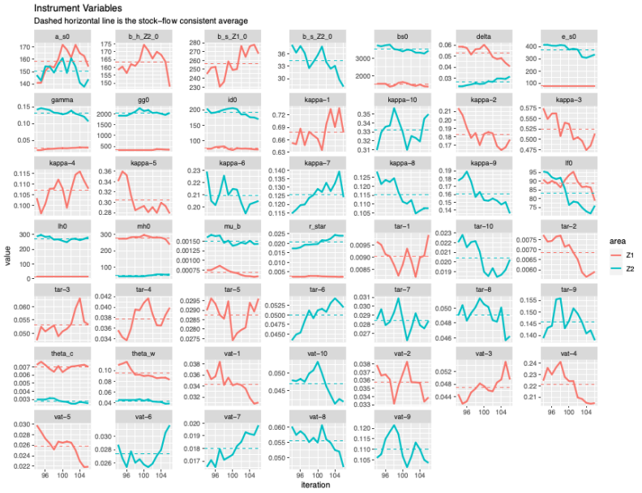

Affiliations: Oriol Vallès Codina (Net Zero Industrial Policy Lab, Johns Hopkins University, 3400 N Charles St. Baltimore, MD 21218) José Bruno R. T. Fevereiro (Banco Nacional de Desenvolvimento Econômico e Social, Brazilian Development Bank) Annina Kaltenbrunner (Leeds University Business School) Effie Kesidou (University of Bath) Andrea Genovese Marco Veronese Passarella (Università L’Aquila, Leeds University Business School)
A complete list of the sectors is provided in Appendix 2
The full description of the equations of the model is presented in appendix 1.
For example, following post-keynesian theory, a constraint is introduced to ensure parameters values for the propensity to consume out of wages is higher than out of profit and, in turn, out of wealth.

